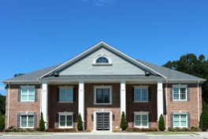
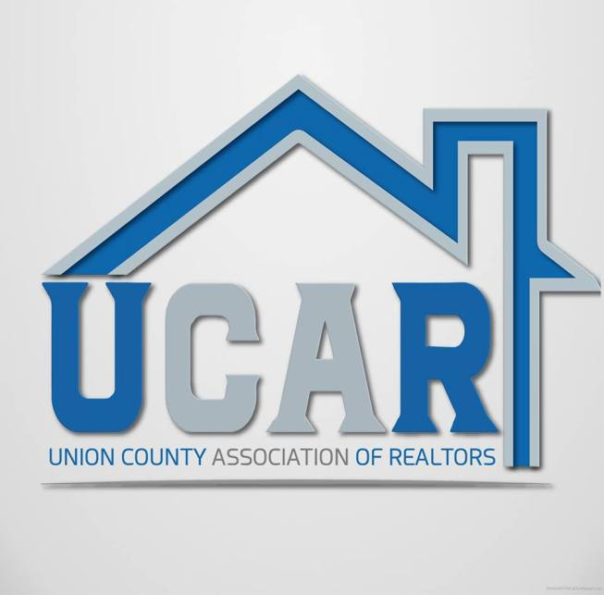
REALTOR® MEMBERSHIP APPLICATION
Union County Association of Realtors®
2627 Brekonridge Centre Dr., Monroe NC 28110 * 704-776-4055 * ucarmonroenc@gmail.com

SECTION I
I hereby apply for: [ ] Primary or [ ] Secondary | [ ] Realtor® or [ ] Designated Realtor® Membership

Name: _________________________________________________________________ Nickname:_____________________

Home address:___________________________________________________________________________________________

Home phone: ________________________ Cell Phone: _______________________ Birthdate: _______________________

E-mail: (Required)________________________________________________________________________________________

Website/URL (Required. If none, please state) ________________________________________________________

Firm name:_______________________________________________________________________________________________

Firm address: ____________________________________________________________________________________________

Firm phone: _______________________ Fax: ________________________ Web site:________________________________

Preferred mailing address (check one): ________ Office _________ Home * Languages spoken:________________
-------------------------------------------------------------------------------------------------------------------------------------------------------------
NC Real Estate License Number: ___________________ Provisional Broker Broker Appraisal (Circle One)

Do you hold licenses (active or inactive) other than the one listed above? ___ Yes ____ No If yes, please list.

Type of license held __________________ State licensed in _______ License No. ____________
-------------------------------------------------------------------------------------------------------------------------------------------------------------
Do you now or have you previously held membership in any other Realtor® Association in the country. If so, please state the Association, type of membership held and the year(s) membership was held. If you have paid dues for any part of this year to that Association please state. ____________________________________________________________________

Have you been found in violation of the Code of Ethics or other membership duties in any association of Realtors® or have any unfulfilled sanctions pending?: _______ If yes, please provide the details as an attachment.

Do you have a record of a recent (within the last 3 years) or a pending bankruptcy? ______ If yes, attach explanation.

Are you a principal, partner, corporate officer or branch office manager? ___________ If yes, you must also complete Section II of this application.

SECTION II – For Designated Brokers/Branch Managers Only

Company Information: [ ] Sole Proprietor [ ] Partnership [ ] Corporation [ ] Limited Liability Company (LLC)
Your position: [ ] Principal [ ] Partner [ ] Corporate Officer [ ] Branch Office Manager

Names of other Partners/Officers of your firm: _________________________________________________________

The firm’s Designated REALTOR® is assessed an annual fee for each active licensee employed by or affiliated with the firm who does not become a REALTOR®. Such salespersons have no membership standing, receive no benefits, and may not use the term REALTOR®.

Member Verification
All applicants to complete and sign

If my application is accepted I agree to complete the association’s mandatory Code of Ethics Orientation course within 90 days of this application, abide by the association’s Bylaws and Policies, and the Code of Ethics of the National Association of Realtors® and the NC Association of Realtors®. I understand that, after the initial requirement, I will be required to complete a Code of Ethics course within specific 2-year periods.

I authorize the association through its directors, committees and/or staff members to make such investigation of my character and credit as it may deem advisable. I acknowledge, consent and fully understand that information obtained as a result of investigation may be reported to the North Carolina Real Estate Commission. I shall not use any information obtained or furnished in connection with such investigation as the basis of any legal action for slander, libel or defamation of character.

For adequate value received and in consideration of being granted membership in the association, I irrevocably waive and release any claim or right of action that I may have or acquire against the association or any of its officers, directors or members, for any act performed in connection with the business of the association and, particularly, as to the acts of the association or any of its officers, directors, or members taken in approving or not approving, advancing, suspending, expelling or otherwise disciplining me as an applicant or member of the association. Further, as an express condition of being granted membership in the Association, I irrevocably waive and release any possible right that I may have to bring any cause of action or claim for libel, slander or defamation that may possibly arise from the filing or consideration of any arbitration request or any ethics complaint that may be brought against me by any Member or by the Grievance Committee of the Association.

I also acknowledge that if accepted as a member and I subsequently resign from the board or otherwise cause membership to terminate with an ethics complaint pending, the Board of Directors may condition renewal of membership upon my certification that I will submit to the pending ethics procedure and will abide by the decision of the hearing panel. If I resign or otherwise cause membership to terminate, the duty to submit to arbitration continues in effect even after my membership lapses or is terminated, provided the dispute arose while I was a Realtor®. Upon the termination of my membership for any cause, I will discontinue the use of the designation "Realtor®." I will also discontinue the use of any designations I have earned through the Realtor® organization.

The association reserves the right to object to any company name or Web site name proposed by a current or potential member, which in the association/MLS’s sole discretion, is confusingly similar to any name used in commerce by the association/MLS that may leave the public confused.

Date: ____/____/____ Signature:___________________________________________________________________

I CERTIFY THAT I HAVE READ THE ABOVE AND THAT ALL INFORMATION FURNISHED BY ME ON THIS
APPLICATION IS TRUE AND CORRECT. I UNDERSTAND AND AGREE THAT FAILURE TO PROVIDE COMPLETE
AND ACCURATE INFORMATION AS REQUESTED, OR ANY MISSTATEMENT OF FACT, SHALL BE GROUNDS FOR REVOCATION OF MY MEMBERSHIP, IF GRANTED. I ALSO CERTIFY THAT I HAVE READ AND AGREE TO ABIDE BY THE CODE OF ETHICS AND THE UCAR BYLAWS.

I agree to pay the established dues as long as I remain a member. I acknowledge that the present application and initial dues are prorated according to the schedule provided with this application and are due with this application. (ALL FEES
AND DUES ARE NON-REFUNDABLE).

By signing below I consent that the Realtor® Association’s (local, state and national) and their subsidiaries, if any (e.g., MLS) may contact me at the specified address, telephone numbers, fax numbers and e-mail address or other means of communication available. This consent applies to changes in contact information that may be provided by me to the association(s) in the future. This consent recognizes that certain state and federal laws may place limits on communications that I am waiving to receive all communications as part of my membership.

Date: ____/____/____ Signature:____________________________________________________________________________

